Veterans – We Want Your Photos

The City of Lynnwood, WA is creating a wrap for a traffic signal box to honor Lynnwood veterans.

We ask you to send photos of veterans/active military members.

Deadline: April 30, 2023

Eligibility: The veteran/active military member lives in Lynnwood or has ever lived at any time in Lynnwood.

Rules / Judging: The History & Heritage Board and other community members will choose photos to go into a signal box wrap project. Photos will be evaluated using the following criteria:
- The veteran/active military member lives or lived in Lynnwood.
- Veteran/active military member must be in uniform in photo
- Photo is family friendly (e.g. no nudity, offensive gestures, etc.)

How to enter: By April 30, 2023, enter at
https://us.openforms.com/Form/eb726454-f3f7-4ba1-8bd0-7671585c0a56

Questions: contact Fred Wong, Arts, Culture and Heritage Coordinator,
fwong@LynnwoodWA.gov 425-670-5502
Example of traffic signal box art
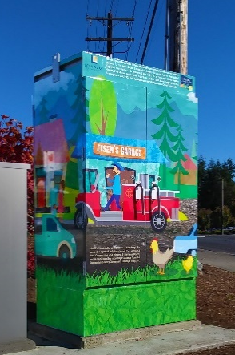
Submission Rules (cont’d)
By entering this Submission, “Submitter” agrees to be bound by the Submission rules and the decisions of the City of Lynnwood (“City”), which are final and binding in all respects and cannot be challenged or appealed.
Submitter represents and warrants that the Submitter is over age 18, owns the Submission photo(s) and the rights to use them, and authorizes the City to use them. Submitter represents and warrants that if there are people under age 18 in the photos, that Submitter is their parent or guardian. And the photo(s), the Submission of the photo(s) in this Submission, and the potential use of the photo(s) by the City do not infringe or violate any rights of any third parties.
City may require Submitter to submit additional material for scanning or photography. The City is not responsible for the failure of any Submissions not received. City reserves the right not to use any of the Submissions.
OWNERSHIP AND LICENSE: All Submission related materials, including submission entries and photos (collectively, “Submission”) shall become the property of the City and will not be acknowledged or returned. The copyright in any Submission, if any, shall remain the property of the Submitter, but Submission into this Submission constitutes Submitter’s irrevocable and perpetual permission and consent, without further compensation or attribution, for the City to use, reproduce, print, publish, transmit, distribute, sell, perform, adapt, enhance, or display such Submission for any purpose, including but not limited to editorial, advertising, trade, commercial, and publicity purposes by the City, in any and all media now in existence or hereafter invented. City and/or others authorized by the City shall have the right to edit, adapt, and modify the Submission.
RELEASE AND INDEMNIFICATION: Submitter waives and releases any and all claims against the City that the Submitter may have for any damages, losses, costs, expenses and other injuries costs and expenses, in whatever form or nature, and including but not limited to any attorneys’ fees, to any person or property, arising out of or in any way resulting from the Submission of the Submission in the Submission or the potential use of the Submission by the City.
Further, to the maximum extent permitted by law, Submitter shall defend, indemnify and hold harmless the City, its elected officials, officers, employees, agents and volunteers from any and all claims, complaints, demands, losses, judgments, liabilities and expenses (including costs and all attorney’s fees) by any and all persons and entities, including without limitation, their respective agents, licensees, or representatives, arising from, resulting from, or connected with this Submission or the City’s potential use of the Submission.

