Mural at North Lynnwood Park – Call for Artists

City of Lynnwood, WA is looking for an artist, or artist team to create a mural at North Lynnwood Park. Selected artist/team will design and paint the mural.

Deadline to apply: April 14, 2024

Eligibility: Open to artists, or artist teams living in WA State. We prefer artist/team to have experience creating murals or large painting projects (at least one team member). No application fee.

Budget: $9,000 (budget is negotiable), which includes creating mural, applying anti-graffiti coating, equipment rentals, supplies, fencing, travel, insurance, permits, taxes, etc. City will pay for power washing the wall in preparation for painting. Artist/s will be required to secure a City of Lynnwood business license.

Location: North Lynnwood Park, 18510 44th Ave W, Lynnwood, WA 98037. North Lynnwood Park is affectionately known as “Dragon Park” because of the dragon spray features at the spray pad next to the restroom.

Selection A panel comprising of arts professionals, Lynnwood Arts Commission members, and City staff will decide based on the applications and interviews. All applicants will be required to submit to and pass a background check.

Themes / requirements:
Themes of mural are dragon(s), water, fantasy. We want the design to be fun for children.
Mural must cover the entire east wall, which is about 8’ tall and 33’ wide.
Mural can use no more than 12 solid colors.
Mural must be created with outdoor paint that can withstand the elements.

How to enter: Fill out application at https://us.openforms.com/Form/f4646035-43dc-4d10-adcf-c00458e42694

Questions: Contact Fred Wong, 425-670-5502, fwong@lynnwoodwa.gov

Timeline
Deadline to apply: April 14, 2024
Artist/team selected: May 28, 2024
Design mural: June 2024
Paint mural: July - August, 2024

Call Rules (Additional)
By entering this Call, “Applicant” (meaning applicant and/or team), agrees to be bound by the call rules and the decisions of the City of Lynnwood “City”, which are final and binding in all respects and cannot be challenged or appealed.
City may require applicant to submit additional material. City is not responsible for the failure of any Applications not received. City reserves the right to pick no one from the Applications.
INDEMNIFICATION: Applicant releases and shall defend, indemnify and hold harmless the City, their elected officials, officers, employees, agents and volunteers for any and all claims, demands, losses, negligent acts or omissions, and liabilities (including costs and all attorney’s fees) to or by any and all persons and entities, including without limitation, their respective agents, licensees, or representatives, arising from, resulting from, or connected with this Call to the extent caused by the negligent acts, unlawful acts, errors or omissions of Applicant. To the maximum extent permitted by applicable law, this shall apply.

North Lynnwood Park, 18510 44th Ave W, Lynnwood, WA 98037 – restroom building is between basketball court and playground.

More photos at https://www.lynnwoodwa.gov/Community/Play-Lynnwood/Arts-Culture-and-Heritage/Artist-Opportunities-Resources/North-Lynnwood-Park-Site-Pics?transfer=95cff9a5-6485-45ae-9577-bf221b2e1cd3
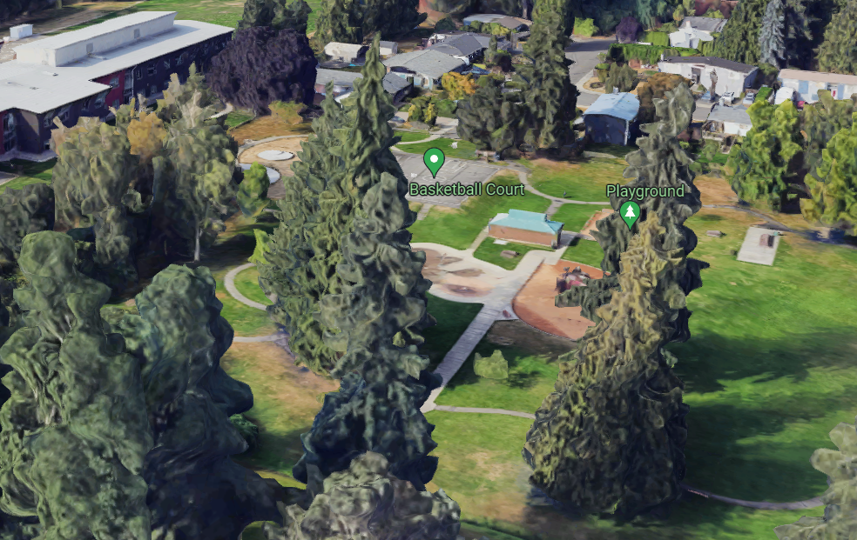

East wall of restroom building, about 8’ h x 33’ w.

